**EJERCICIO 1:**

USE `employees`;

DROP function IF EXISTS `sueldo_medio`;

DELIMITER $$

USE `employees`$$

CREATE DEFINER=`root`@`localhost` FUNCTION `sueldo_medio`(numero char(4)) RETURNS varchar(100) CHARSET utf8mb4

DETERMINISTIC

BEGIN

DECLARE resultado varchar(100) default 'DEPARTAMENTO DESCONOCIDO';

DECLARE s1 DOUBLE;

DECLARE s2 DOUBLE;

SELECT ROUND(AVG(s.salary)) INTO s1

FROM salaries s INNER JOIN dept_emp de

ON s.emp_no=de.emp_no

WHERE de.dept_no=numero;

SELECT ROUND(AVG(s.salary)) INTO s2 FROM salaries s;

IF s1 > s2

THEN

SELECT CONCAT("DEPT: ", numero, " | SUELDO MEDIO: ", ROUND(AVG(s.salary)), " | SUELDO SUPERIOR A LA MEDIA") INTO resultado

FROM salaries s INNER JOIN dept_emp de

ON s.emp_no=de.emp_no

WHERE de.dept_no=numero;

ELSE

SELECT CONCAT("DEPT: ", numero, " | SUELDO MEDIO: ", ROUND(AVG(s.salary)), " | SUELDO SUPERIOR A LA MEDIA") INTO resultado

FROM salaries s INNER JOIN dept_emp de

ON s.emp_no=de.emp_no

WHERE de.dept_no=numero;

END IF;

RETURN resultado;

END$$

DELIMITER ;

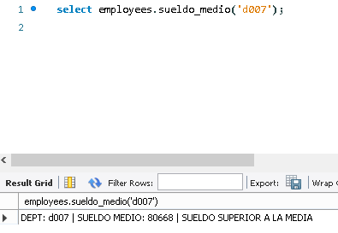

**EJERCICIO 2:**

USE `employees`;

DROP procedure IF EXISTS `manager_departamento`;

DELIMITER $$

USE `employees`$$

CREATE DEFINER=`root`@`localhost` PROCEDURE `manager_departamento`(numero char(6))

BEGIN

DECLARE nombre VARCHAR(20);

DECLARE num_dep VARCHAR(20);

DECLARE empleados VARCHAR(20);

IF (SELECT dm.dept_no dm FROM dept_manager dm WHERE dm.emp_no=numero) IS NOT NULL

THEN

SET nombre = (SELECT dp.dept_name FROM departments dp

INNER JOIN dept_manager dm

ON dm.dept_no=dp.dept_no

WHERE dm.emp_no = numero);

SET num_dep = (SELECT dept_no FROM dept_manager WHERE emp_no=numero);

SET empleados = (SELECT COUNT(*) FROM employees e

INNER JOIN dept_emp de

ON de.emp_no=e.emp_no

WHERE de.dept_no = num_dep);

SELECT CONCAT("NOMBRE DE LOS DEPARTAMENTOS: ", nombre) AS NOMBRES;

SELECT CONCAT("TOTAL DE EMPLEADOS ACTUALES: ", empleados) AS EMPLEADOS;

ELSE

SELECT CONCAT("NO HA DIRIGIDO NUNCA UN DEPARTAMENTO") AS RESULTADO;

END IF;

END$$

DELIMITER ;

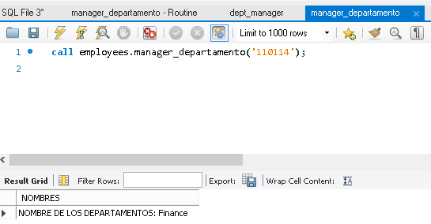

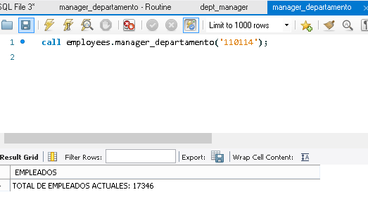

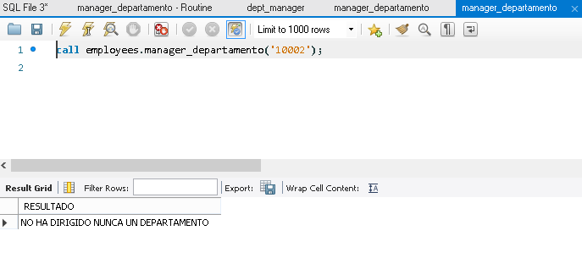

**EJERCICIO 3:**

USE `employees`;

DROP function IF EXISTS `gastos_departamento`;

DELIMITER $$

USE `employees`$$

CREATE DEFINER=`root`@`localhost` FUNCTION `gastos_departamento`(numero char(4)) RETURNS varchar(100) CHARSET utf8mb4

DETERMINISTIC

BEGIN

DECLARE resultado varchar(100) default 'DEPARTAMENTO DESCONOCIDO';

SELECT CONCAT("DEPT: ", numero, " | GASTO EN SALARIOS ", SUM(s.salary)) INTO resultado

FROM salaries s INNER JOIN dept_emp de

ON s.emp_no=de.emp_no

WHERE de.dept_no=numero;

RETURN resultado;

END$$

DELIMITER ;

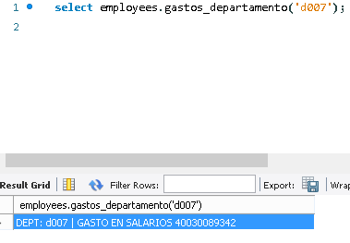

**EJERCICIO 4:**

USE `employees`;

DROP procedure IF EXISTS `datos_empleado`;

DELIMITER $$

USE `employees`$$

CREATE DEFINER=`root`@`localhost` PROCEDURE `datos_empleado`(numero char(6))

BEGIN

DECLARE nombre VARCHAR(20);

DECLARE num_dep VARCHAR(20);

DECLARE empleados VARCHAR(20);

IF (SELECT dm.dept_no dm FROM dept_manager dm WHERE dm.emp_no=numero) IS NOT NULL

THEN

SET nombre = (SELECT dp.dept_name FROM departments dp

INNER JOIN dept_manager dm

ON dm.dept_no=dp.dept_no

WHERE dm.emp_no = numero);

SET num_dep = (SELECT dept_no FROM dept_manager WHERE emp_no=numero);

SET empleados = (SELECT COUNT(*) FROM employees e

INNER JOIN dept_emp de

ON de.emp_no=e.emp_no

WHERE de.dept_no = num_dep);

SELECT CONCAT("NOMBRE DEL DEPARTAMENTO QUE DIRIGE: ", nombre) AS DATOS;

SELECT CONCAT("TOTAL DE EMPLEADOS ACTUALES: ", empleados) AS EMPLEADOS;

SELECT CONCAT("NOMBRE: ", e.first_name, " ", e.last_name) AS EMPLEADOS

FROM employees e

INNER JOIN dept_emp de

ON de.emp_no=e.emp_no

WHERE de.dept_no = num_dep;

ELSE

SELECT CONCAT("NO DIRIGE NINGÚN DEPARTAMENTO") AS RESULTADO;

END IF;

END$$

DELIMITER ;

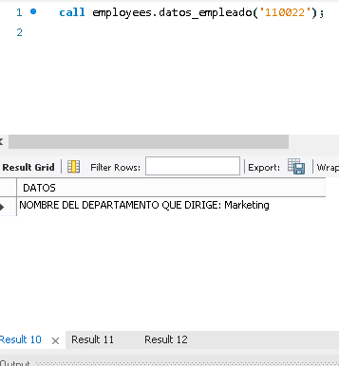

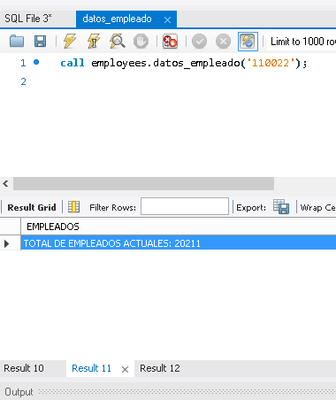

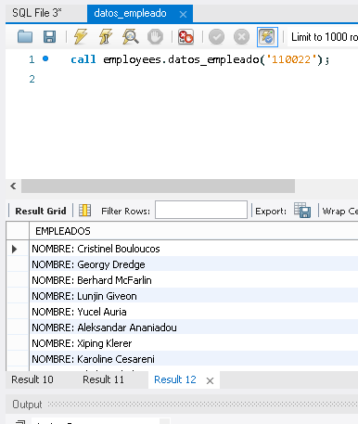

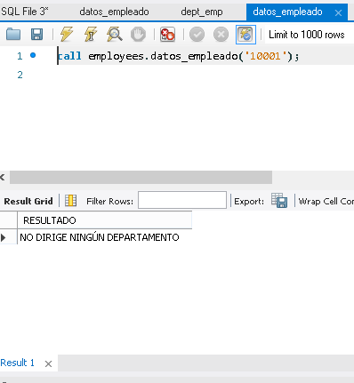

**EJERCICIO 5:**

USE `employees`;

DROP procedure IF EXISTS `contratos`;

DELIMITER $$

USE `employees`$$

CREATE DEFINER=`root`@`localhost` PROCEDURE `contratos`(fecha1 DATE, fecha2 DATE)

BEGIN

SELECT CONCAT(MONTHNAME(e.hire_date), " ", YEAR(e.hire_date), ": ", COUNT(*), " contrataciones") AS CONTRATOS FROM employees e

WHERE (e.hire_date>=fecha1 AND e.hire_date<=fecha2)

GROUP BY MONTH(e.hire_date), YEAR(e.hire_date)

ORDER BY e.hire_date;

END$$

DELIMITER ;

